Subject: Science Year: Phase 3 year A Light
NC/PoS:
- recognise that light appears to travel in straight lines
- use the idea that light travels in straight lines to explain that objects are seen because they give out or reflect light into the eye
- explain that we see things because light travels from light sources to our eyes or from light sources to objects and then to our eyes
- use the idea that light travels in straight lines to explain why shadows have the same shape as the objects that cast them
Prior Learning (what pupils already know and can do)
We need light in order to see things and that dark is the absence of light. That light is reflected from all surfaces. That light from the sun can be dangerous and by wearing sunscreen, avoiding the sun in the middle of the day, the body is protected. The eyes can be protected through wearing sunglasses that filter UV light and wearing a hat with a brim. Shadows are formed when the light from a light source is blocked by an opaque object and the size of shadow changes depending on where the light source is.
End Goals (what pupils MUST know and remember)
- Know light is a form of energy
- Know light travels in straight lines
- Know objects are seen because they emit or reflect light into our eyes
- Know light that is not reflected by a surface is absorbed
- know that light travels from light sources to our eyes and from light sources to objects and then to our eyes
- know because light travels in straight lines that shadows will have the same shape as the objects that cast them
- Know how to use diagrams and models to describe how light travels in straight lines
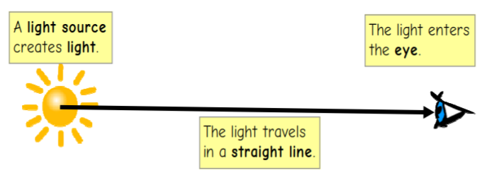
- Know how to use diagrams and models to describe how light travels in straight lines when reflected from other objects
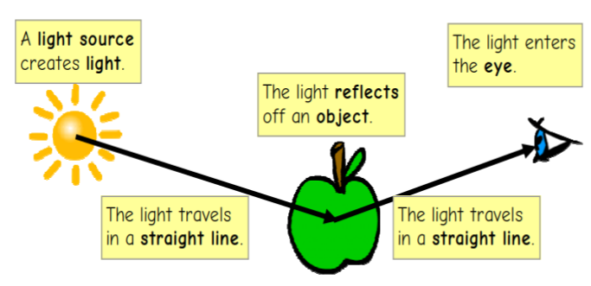
- Know how to use models and diagrams to describe light travelling in straight lines past an opaque/translucent object to cast a shadow of the same shape
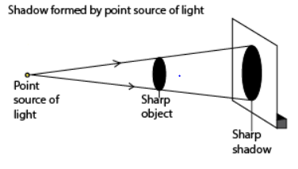
Key Vocabulary: travel, straight, light rays, light source, eye, emit, reflect, reflective, absorb, surfaces, object, cast , height, width, prism, refraction
Week 1: Recap: How are shadows formed? (opaque object blocks the light rays to form a shadow) How does the size of the shadow change? Name light sources: natural and artificial
Children recognise that light travels in straight lines and is a form of energy
Suggested activities:
- https://www.youtube.com/watch?v=zLj35KNpMcg light travels in straight lines – children repeat with 3 pieces of card, torch, blue tac
- Children have a piece of hose to shine light through, repeat but this time bend the hose
- Use mirrors to direct light onto an object
Children write up how the above activities prove light travels in straight lines

Vocabulary: travel, straight
Week 2: Recap: How does light travel? Name light sources
Children learn objects are seen when they emit light
Suggested activities:
Children draw diagrams using different light sources
Vocabulary: light rays, light source, eye, emit
Week 3: Recap: how do we see light sources?
Children learn objects are seen because they give out or reflect light into our eyes and light that is not reflected by a surface, is absorbed
https://www.youtube.com/watch?v=1PsHHKwtXQU Tigtag video
Suggested activities:
- https://www.youtube.com/watch?v=LAbAk5Ab674 up to 2:00 reflection and absorption
- Children try reflecting light off different surfaces to see which reflect and absorb light include scrunched up tin foil, black fabric etc
Vocabulary: reflect, reflective, absorb, surfaces
Week 4: Recap: which surfaces reflect lots of light? Mirrors, shiny surfaces. Which surfaces don’t?
Children learn that light travels from light sources to objects and then to our eyes
Suggested activities:
Children create models to show the above
Vocabulary: object
Week 5: Recap: how do we see objects that are not light sources?
Children use models and diagrams to describe light travelling in straight lines past an opaque/translucent object to cast a shadow of the same shape
Children investigate size of shadows: prediction, collecting data and presenting evidence in a line graph

Suggested activities:
Children change the distance of the light source to the object and measure the size of the shadow (height and width) or change the distance of the object from the wall
Children use an opaque or translucent object
N.B the shape is the same just the size changes
Vocabulary: cast , height, width
Week 6: Recap: how are shadows formed?
Children explore refraction and light phenomena
Children learn about objects looking bent in water - refraction

Suggested activities:
- Watch https://www.youtube.com/watch?v=95V-QJYZ2Dw
Children complete refraction investigations and record their results
Children answer: What happens when light travels from air into another transparent material, such as glass, plastic or water?
- Give children torches, white card and prisms. When light travels from air through a transparent material, it refracts, or bends. Children describe and explain their observations.
- https://www.youtube.com/watch?v=YcvJkzGME6I coin trick
Vocabulary: prism, refraction
Link to career scientist:
Laser technician

