Subject: Science Year: Phase 1 (Year A) Everyday Materials Unit 3/6
EYFS: ELG
- Explore the natural world around them, making observations and drawing pictures of animals and plants
- Know some similarities and differences between the natural world around them and contrasting environments, drawing on their experiences and what has been read in class
- Understand some important processes and changes in the natural world around them, including the seasons

NC/PoS:
- distinguish between an object and the material from which it is made
- identify and name a variety of everyday materials, including wood, plastic, glass, metal, water, and rock
- describe the simple physical properties of a variety of everyday materials
- compare and group together a variety of everyday materials on the basis of their simple physical properties.
- Explore the natural world around them, making observations and drawing pictures.
- Know some similarities and differences between the natural world around them and contrasting environments, drawing on their experiences and what has been read in class.
Prior Learning (what pupils already know and can do)
Can group collections of materials with similar and/ or different properties. Can discuss differences between materials.
End Goals (what pupils MUST know and remember)
- know objects are things we can see or touch and can be made from one or more materials
- know a material is the matter from which a thing is or can be made from
- know a natural material is any product that comes from plants, animals, or the ground
- know examples of natural materials are water, wood, rock, cotton, iron, oil, leather
- know manufactured materials are materials that have been produced by man
- know examples of manufactured materials are plastic, metal, glass, brick, paper, fabric, foil
- Know that everything is made up of materials
- Know materials can be grouped according to their properties
- Know varied materials, have different properties
- Name different properties: hard/soft; stretchy/stiff; shiny/dull; rough/smooth; bendy/not bendy; waterproof/not waterproof; absorbent/not absorbent; opaque/transparent
Key Vocabulary: object, material, plastic, metal, glass, brick, paper, fabric, foil, water, wood, rock, cotton, iron, oil, leather, air, natural, manufactured, ice, silk, paint, sponge, fur, feather, sand, wool, concrete, property, hard/soft; stretchy/stiff; shiny/dull; rough/smooth; bendy/not bendy; waterproof/not waterproof; absorbent/not absorbent; opaque/transparent, flexible
Session 1: Give the children different materials to sort
Children learn to distinguish between object and material. Objects are things we can see or touch and can be made from one or more materials and a material is the matter from which a thing is or can be made from
Suggested resources:
https://www.youtube.com/watch?v=7puHegpyGbY objects and materials
https://www.youtube.com/watch?v=8uM_RU3vzXU Objects are made of materials

Vocabulary: object, material
Session 2: Recap: what is the difference between an object and a material? Name at least six of each.
Children learn to group objects through observation
Suggested activities:
Group objects according to material – include balloon filled with air and one filled with water, use a variety of household objects and ones from school
Observe & interact with natural processes, such as looking at the effect of heat/cold with melting ice, freezing water, toast. Manipulate some materials such as Play-Dough and describe how they change – squash, stretch, bend, twist.

Children can record in their own way.
Vocabulary: plastic, metal, glass, brick, paper, fabric, foil, water, wood, rock, cotton, iron, oil, leather, air
Session 3: Recap: How might we group materials?
Children learn a natural material is any product that comes from plants, animals, or the ground: examples are water, wood, rock, cotton, iron, oil, leather
Manufactured materials are materials that have been produced by man: examples of manufactured materials are plastic, metal, glass, brick, paper, fabric, foil

Suggested resources:
https://www.youtube.com/watch?v=0yKoHAWVhuE Natural and manmade materials
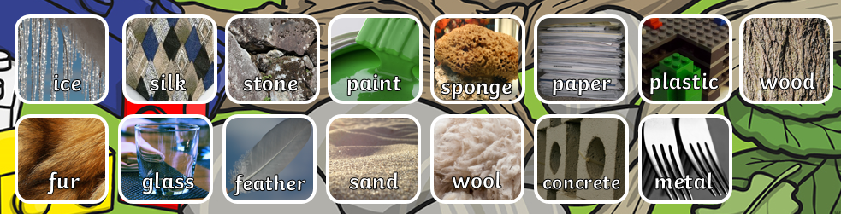

Identifying, classifying and grouping Be able to ask a Yes/No questions to aid sorting. Identify the headings for the two groups (it is …., it is not ….). Be able to compare on obvious, observable features e.g. size, shape, colour, texture etc.

Vocabulary: natural, manufactured, ice, silk, paint, sponge, fur, feather, sand,
wool, concrete
Session 4: Recap: what is the difference between a manufactured and manmade material? Give examples
Children learn that everything is made up of materials and materials can be grouped according to their properties

Suggested resources:
https://www.youtube.com/watch?v=340MmuY_osY Materials and their properties
Children sort a variety of materials
Vocabulary: property, hard/soft; stretchy/stiff; shiny/dull; rough/smooth; bendy/not bendy; waterproof/not waterproof; absorbent/not absorbent; opaque/transparent, flexible
Session 5: Recap: Name properties of different materials

Children learn to name different properties: hard/soft; stretchy/stiff; shiny/dull; rough/smooth; bendy/not bendy; waterproof/not waterproof; absorbent/not absorbent; opaque/transparent

Suggested activity:
Children complete a material walk around the school
Give the children a property on card and they locate materials which have that property

Vocabulary: property, compare
Session 6: Recap: name a property – which materials have this property? Etc.
Children perform simple tests to explore questions about materials

Suggested activities:
Fair and comparative testing.
Provide the children with a variety of materials and get them to predict which one would be most suitable. Test their predictions.
What is the best material for an umbrella?
What is the best material for lining a dog basket?
What is the best material for curtains?
What is the best material for a bookshelf?

Vocabulary: prediction, predict, simple test
Link to career scientist:
https://pstt.org.uk/application/files/1116/2851/6355/Materials_scientist_-_Pearl_Agyakwa.pdf

